
S T A R D Y N A M I C I N V E S T M E N T S
THE
THREE-PILLAR
PORTFOLIO
THE DIVERSIFICATION PLAYBOOK FOR
AUSTRALIAN INVESTORS
How to build a property portfolio that works in any market!


C O N T E N T S
TABLE OF CONTENTS
INTRODUCTION
THE DIVERSIFICATION QUESTION 3
CHAPTER 1
WHY “JUST BUY ANOTHER ONE” ISN’T A STRATEGY 4
CHAPTER 2
PILLAR ONE: HIGH-YIELD PROPERTY 5
CHAPTER 3
PILLAR TWO: BLUE-CHIP PROPERTY 8
CHAPTER 4
PILLAR THREE: HIGHER-GROWTH PROPERTY 10
CHAPTER 5
THE THREE PILLARS AT A GLANCE 13
CHAPTER 6
BUILDING YOUR BLEND 14
CHAPTER 7
YOUR NEXT STEP 15

L E T’S B E G I N
THE DIVERSIFICATION QUESTION
EVERY INVESTOR FACES


Most Australian property investors reach the same fork in the road. They already own one property, maybe two, and they know they want to keep building. So, they do the obvious thing: they go looking for “another one just like it.”
It’s not a bad instinct. It’s just an incomplete one.
The investors who build genuinely resilient portfolios tend to ask a different question first. Not “where’s my next property?” but “what role does my next property need to play?” Income? Growth? Stability? A hedge against the property they already hold?
The strongest portfolios aren’t built from one type of property - they’re built from a deliberate mix.
This guide walks through three distinct ways property can work for you, how they complement each other, and why the investors with the strongest portfolios usually aren’t choosing one, they’re blending them, deliberately, based on where they are in their journey.
By the end, you won’t just understand the three pillars. You’ll have a clear sense of which mix might suit you, and a way to get a second, sharper opinion on it.
Hopefully I will also be able to show you the power of diversification within an investment portfolio, not just within locations but also asset types and classes, and possibly even income sources.

T H E C A S E F O R D I V E R S I F I C A T I O N
WHY “JUST BUY ANOTHER ONE”
ISN’T A STRATEGY

Concentration feels safe because it’s familiar. If your first investment property worked out, buying a second one that looks just like it feels like doubling down on a winning formula.

But a portfolio of near-identical properties isn’t diversified, it’s duplicated. If interest rates, local supply, or a single state’s conditions shift against you, every property in the portfolio tends to move the same way, at the same time.

Genuine diversification means owning assets that respond differently to the same conditions:
- Some that generates strong cash flow when rates rise and equity growth stalls
- Some that holds their value and keeps compounding steadily through cycles
- Some that captures outsized growth when conditions are right, even though it carries more short-term volatility

None of these are “the best” property type in isolation. Each earns its place by doing a job the others can’t. The skill isn’t picking the single best asset; it’s building a mix where the strengths of one offset the weaknesses of another.

ROLE | WHAT IT DOES
Income | Cash flow to fund your portfolio’s growth
Stability | Reliable, lower-volatility long-term growth
Growth | Higher upside for investors who can wear the swings



P I L L A R O N E
HIGH-YIELD PROPERTIES


For many Australian investors, the biggest handbrake on building a portfolio isn’t finding the next property, it’s servicing the ones they already own. Negatively geared properties are almost a requirement here in Australia, with the cost of the properties so high, but they quietly draw down your cash flow every month which not only limits how fast you can borrow again but can be downright expensive to hold.

High-yield property flips that equation. By prioritising strong rental returns over rapid capital growth, this strategy is designed to generate cash flow that can help offset the shortfall from your negatively geared holdings, improving your serviceability and giving you more room to keep investing.
High-yield property is not necessarily the “best” property in isolation. Its value comes from balance. Where a blue-chip property may act as a stable long-term anchor, and a higher-growth property may aim for stronger capital gains, a high-yield asset can help make the overall portfolio easier to hold, finance and expand.
What is a high-yield property?
Rental yield is the annual rent received from a property compared with its purchase price. A simple way to think about gross yield is:
Gross rental yield =
(Annual rental income ÷ Purchase price) × 100

For example, a property purchased for $500,000 that earns $650 per week in rent produces annual rent of $33,800.
Gross rental yield = (33,800 ÷ 500,000) × 100
Gross rental yield = 6.76%

Now, that figure is only a starting point. Investors also need to account for expenses such as interest payments, council rates, insurance, repairs, property management, vacancies and any strata or body corporate fees. The more useful question is not simply, ‘what is the advertised yield?’ but ‘after realistic costs, how much does this property contribute to, or draw from, my cash flow?’
High-yield opportunities are commonly found where purchase prices are more accessible relative to rents, where tenant demand is strong, or where an investor can improve the property’s income through a legitimate value-add strategy. This may include dual income configurations, well located regional housing, carefully selected rooming arrangements where permitted, or properties with secondary dwelling potential, subject to planning rules, finance requirements and proper due diligence.

Another excellent source of high-yield properties is the U.S. residential market. With property prices throughout the Mid-west significantly more affordable, it can be easy to find properties yielding 10%+ even after costs.


Why income matters
 | It can reduce portfolio holding costs  Every portfolio has a carrying cost. When rent does not cover loan repayments and operating expenses, the owner needs to fund the gap personally. A couple of negatively geared properties may be manageable. Several properties with large ongoing shortfalls can quickly become a constraint.  A well selected high yield asset can help offset some of that pressure. Its rent may contribute toward its own expenses and, in some cases, reduce the overall cash-flow deficit created by lower yielding properties elsewhere in the portfolio.
  1

 | It may support borrowing capacity  Lenders assess income, living costs, existing debts and rental income when determining how much an investor may be able to borrow. A property that produces stronger rent can improve the income side of that assessment compared with a similar priced property earning substantially less rent.  The exact outcome depends on the lender, loan structure, interest rates, personal circumstances and lending policy at the time. Still, the principle is straightforward: stronger recurring rental income can create more room in a portfolio than an asset that requires a large monthly top-up.  That is why high yield property can be especially useful for investors who already own capital growth focused assets. The right income producing asset does not merely add another property to the portfolio; it may help unlock the capacity to make the next strategic move.
  2

 | It provides resilience when conditions change  Property markets and economic conditions can certainly change. Interest rates can rise, rents can soften in some locations, and personal circumstances can change. A portfolio built only around future capital growth is more exposed if cash flow becomes tight before that growth can be realised.  Strong rental income can provide a buffer. It may help an investor manage periods of higher interest costs, reduce reliance on personal income, and avoid being forced to sell an otherwise good asset at the wrong point in the market cycle. This does not eliminate risk; every property investment carries risk. The aim is to avoid unnecessary fragility. A portfolio with a reliable income component may give its owner more choices when conditions are less favourable.
  3

 | It can support a longer-term strategy  Capital growth is often most powerful over long holding periods. But holding for the long term is easier when the portfolio is not continually draining cash.  High yield property can help bridge the gap between today’s holding costs and tomorrow’s potential equity growth. It may allow an investor to stay invested, reinvest surplus cash flow, build a maintenance buffer, or direct funds toward deposits and acquisition costs for future purchases.  In that sense, cash flow is not the opposite of growth. It can be one of the mechanisms that makes growth-based investing sustainable over time.
  4

The trade-off: yield is not the whole story

A high yield property should never be treated as an automatic green flag. Sometimes a high yield due to a low purchase price may be there for a good reason: weak population growth, limited employment opportunities, oversupply, poor tenant quality, high vacancy risk, substantial maintenance needs or an uncertain resale market.

Before buying, look beyond the headline rent and ask:
- Is the rental demand genuine and supported by local employment, amenities and population?
- How long are comparable properties taking to lease?
- Is there a large amount of new supply that could put pressure on rents or values?
- Are the rent estimates supported by current, comparable leased properties?
- What will the net cash flow look like after all realistic expenses?
- How easy will it be to sell if the strategy or personal circumstances change?
- Does the property complement the rest of the portfolio, or simply add more exposure to the same risk?

A high yield strategy also often requires more active ownership than a straightforward blue-chip buy and hold property. It may demand closer management, more frequent tenant turnover, more detailed local market research, and a willingness to solve operational issues quickly. The additional income should compensate appropriately for that additional complexity.
WHAT IT TYPICALLY LOOKS LIKE
- Rental yields meaningfully above the market average
- Purchase prices that make strong yield achievable
- More active management than a ‘buy and hold’ blue-chip asset
- Slower capital growth; the trade-off for the cash flow

WHO IT TENDS TO SUIT
High-yield property can be particularly relevant for investors who:
- Already own one or more negatively geared properties.
- Want to reduce the portfolio’s monthly cash-flow drain.
- Need to protect or improve serviceability before their next acquisition.
- Value income and flexibility alongside long-term equity growth.
- Are prepared to undertake more detailed due diligence and, where needed, more active asset management.
It may be less suitable for an investor whose sole priority is premium location capital growth, or someone who does not have the appetite for the operational work that can accompany higher-income assets.
Generally, higher-yielding assets are best as a complement to high-growth assets, not necessarily the best strategic buy for your first property or two.

The right income asset doesn’t just pay you - it unlocks your next purchase.
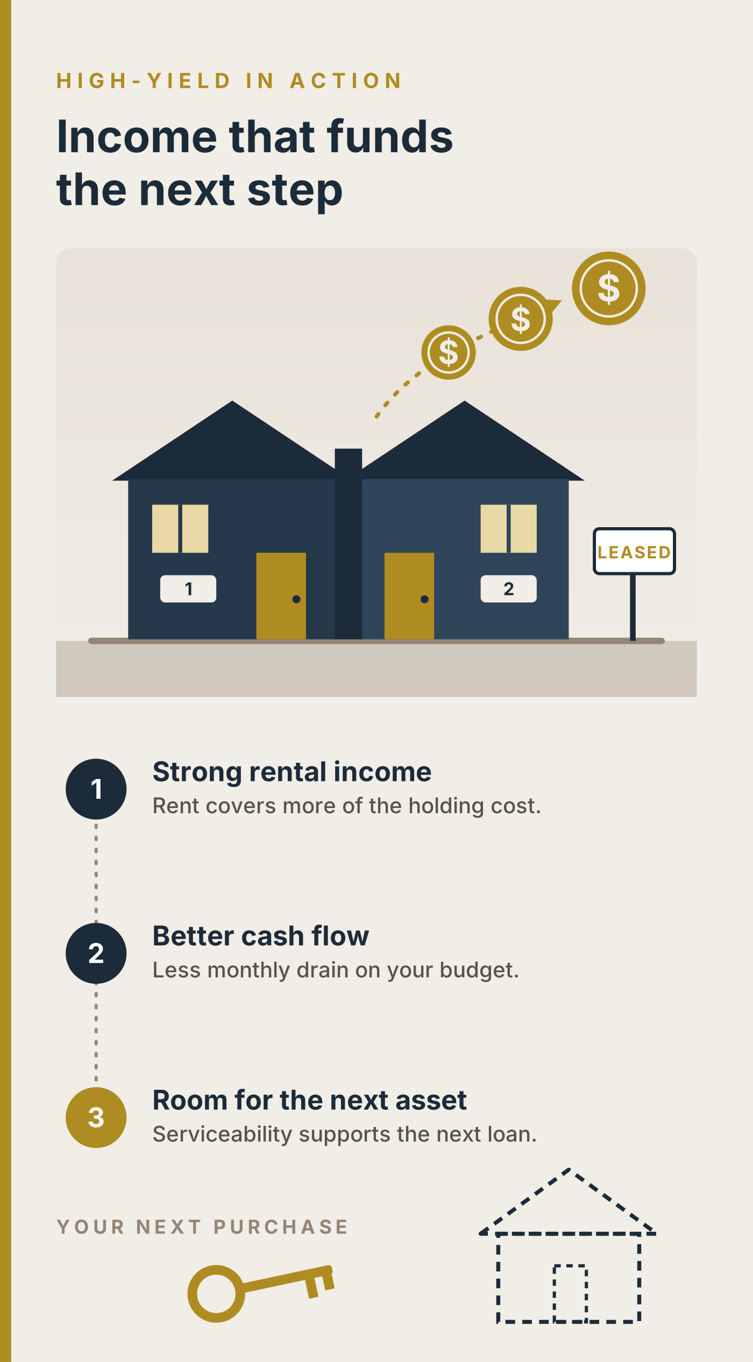

P I L L A R T W O
BLUE-CHIP PROPERTIES


Blue-chip property is the portfolio’s ballast, designed to provide stability and dependable long-term compounding growth while other assets perform more specialised roles. In a diversified portfolio, its purpose is not to produce the strongest immediate cash flow or chase the biggest short-term uplift, it is the reliable core an investor can hold through changing market conditions.

These are properties in established, tightly held markets with long track records: consistent long-term capital growth, deep pools of buyers and tenants, and a resilience through economic cycles built on decades of proven demand. The trade-off is yield. Blue-chip property rarely produces strong cash flow, because the price reflects the market’s confidence in its long-term growth.

The case for a blue-chip core
A blue-chip property is built around a simple principle: quality assets in locations people consistently want to live in attract demand over the long term. Rather than relying on a single catalyst, such as a new infrastructure project, a mining boom or an expected population surge, these locations have already demonstrated their appeal over many years.
That consistency matters because property investing is a long game. Markets may pause, soften or move unevenly from suburb to suburb, but an established market with multiple sources of demand is generally less dependent on one employer, one industry or one short-term narrative.
For an investor, this creates confidence to hold. And holding quality property through multiple cycles is often more important than trying to predict every peak and trough.

Why blue-chip assets can be more resilient
Blue-chip property tends to have several advantages that support its role as a stabiliser within a diversified portfolio:
- Deep buyer demand: Owner occupiers, investors and downsizers may all compete for the same well-located property.
- Reliable tenant demand: Established suburbs often appeal to tenants because they offer convenience, amenities and connection to work, education and lifestyle.
- Relative scarcity: In mature suburbs, there may be very limited land available for new supply, particularly for detached houses or well-positioned dwellings.
- Liquidity: When it is time to sell, a property in a recognisable, desirable location may have a broader pool of potential buyers than a more specialised or remote asset.
- Lower volatility: Values can still fall or stagnate, but established locations may experience less dramatic swings than emerging or highly speculative markets.
The key word is relative. Blue-chip property is not immune from interest rate changes, economic conditions, local oversupply or poor buying decisions. A premium location does not automatically make every property within it a good investment. The asset still needs to be bought at a sensible price, have a sound layout and condition, and meet the needs of the people likely to buy or rent it.
The trade-off: stability often comes at a cost
Because buyers place a premium on confidence, location and scarcity, blue-chip property commonly has a lower rental yield relative to its purchase price. The investor may need to contribute more of their own cash to hold it, particularly when interest rates are high.
This does not make the asset ‘bad’ for cash flow, it simply means its primary job is different. A high-yield property may contribute income and improve serviceability. A blue-chip property may contribute equity growth, stability and a dependable base of value over time. Strong portfolios often use both roles deliberately rather than expecting one property to deliver everything.
Blue-chip properties can also appear less exciting in the short term. They may not have a dramatic story, a flashy headline yield or the promise of an instant transformation. Their appeal is often quieter: consistent demand, a quality location and the potential to compound patiently over a long period.
What to look for
When assessing a potential blue-chip property, focus on enduring demand rather than temporary hype:
- Is the location desirable for more than one type of buyer or tenant?
- Are jobs, transport, schools, shops, health services and lifestyle amenities already accessible?
- Is the local area largely built out, with constrained supply of comparable properties?
- Does the property have broad appeal, such as practical layout, parking, usable outdoor space and reasonable proximity to amenities?
- Are there risks that could undermine the location’s appeal, such as excessive new apartment supply, flood exposure, major road noise or restrictive planning issues?
- Can the investor comfortably hold the property if rents, rates or interest costs change?

The strongest blue-chip purchase is usually one that remains attractive even if the market does not immediately rise. In other words, it should be an asset an investor would still be comfortable owning if growth took longer than expected.
WHO THIS PILLAR TENDS TO SUIT
Blue-chip property may suit investors who:
- Want a core, long-term holding that supports portfolio stability.
- Have a patient investment horizon and are less focused on immediate yield.
- Value established demand and easier resale potential.
- Want to reduce reliance on higher-risk or more actively managed investments.
- Are building the foundation of a diversified portfolio before adding income-focused or higher-growth assets.

A blue-chip asset is the cornerstone of a solid portfolio. When paired with a high-yield property that supports cash flow and, later, a carefully chosen higher-growth asset, it can help create a portfolio with income, stability and upside working together.

This style of property can make an excellent starting point if affordable and lays solid foundations for further development and future growth.

Blue-chip isn’t exciting. That’s precisely the point.
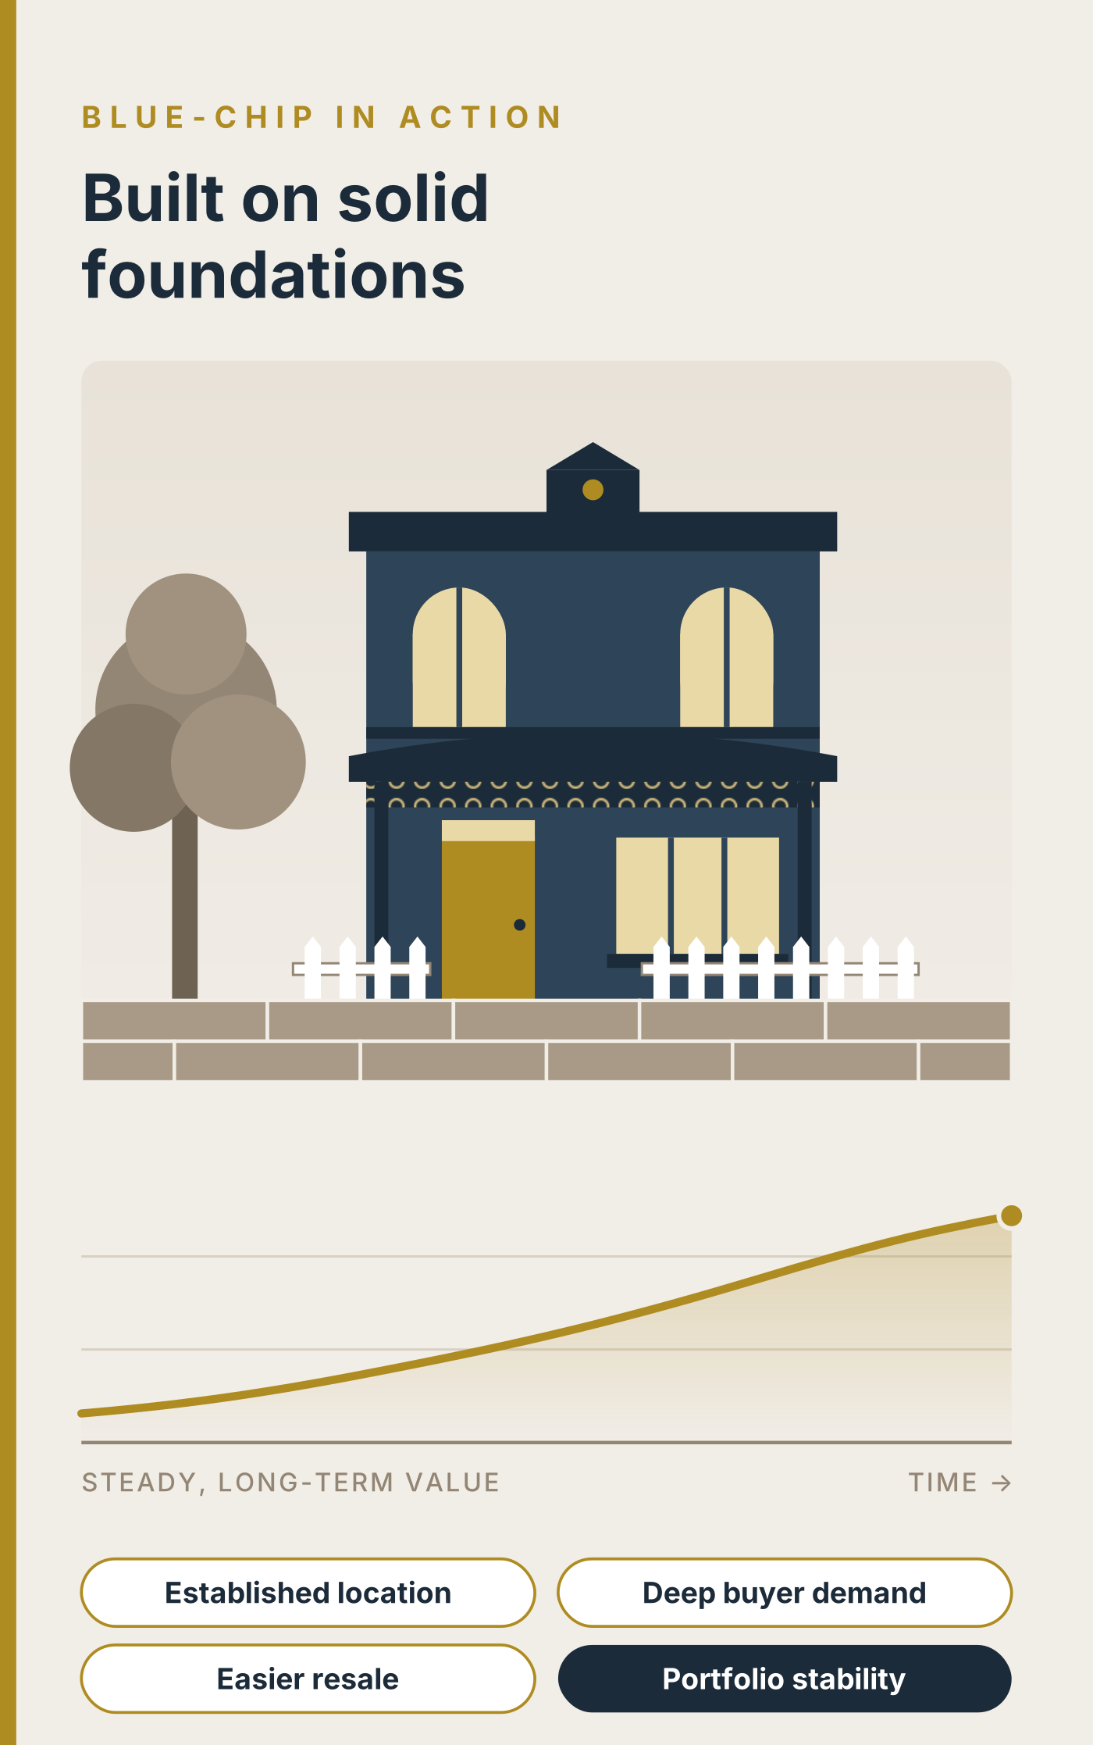

P I L L A R T H R E E
HIGHER-GROWTH PROPERTY


Higher-growth property has a different job from the other two pillars. Where high-yield property is intended to support portfolio income, and blue-chip property provides stability, a higher-growth asset is selected for its potential to create a stronger uplift in equity over time.

These opportunities are often found in markets earlier in their development or growth cycle, areas experiencing meaningful changes in population, employment, infrastructure, affordability or buyer demand. The appeal is clear: if the underlying drivers prove durable, capital growth may outpace more mature, established markets. The trade-off is that this potential comes with more uncertainty, more volatility and a greater need for careful research.
What creates growth potential?
Property prices do not rise simply because an area is being talked about. Sustainable growth generally requires a mismatch between demand and available supply, supported by real economic and lifestyle fundamentals.
A higher-growth market may have several drivers working together:
- Population growth: More people moving into an area can increase demand for both rentals and owner-occupied homes.
- Employment and economic activity: New jobs, expanding industries or improved access to employment centres can strengthen the local buyer pool.
- Infrastructure investment: Transport links, hospitals, schools, retail precincts and community amenities can make an area more accessible and desirable.
- Relative affordability: Buyers priced out of premium markets may look to nearby or comparable locations where their budget stretches further.
- Changing lifestyle preferences: Remote work, regional migration, family-oriented amenities or proximity to recreation can reshape demand.
- Restricted or lagging supply: Growth is more likely to be supported where new housing supply cannot rapidly overwhelm buyer and tenant demand.
No single factor is enough by itself. A new train station, for example, is not automatically an investment case. The question is whether it improves access to jobs and amenities, whether people genuinely want to live nearby, and whether a large volume of new dwellings will arrive at the same time.
The attraction: equity growth
The central purpose of a higher-growth property is to build equity. Equity is the difference between a property’s market value and the debt secured against it. If an asset rises in value while the loan remains fixed or reduces over time, the owner’s equity position improves.
That equity can potentially provide options later: refinancing, funding a deposit for another acquisition, completing renovations, or simply strengthening long-term wealth.
A higher-growth asset is usually not intended to deliver immediate cash-flow comfort. Like blue-chip property, its rental yield may be modest relative to the purchase price. Investors need to be confident they can hold it through periods when values plateau, costs rise or market sentiment changes.

The price of higher potential
Higher projected growth always deserves scrutiny. Markets with greater upside potential can also be more sensitive to rising interest rates, weaker economic conditions, changes in lending policy, local oversupply or a decline in a key industry.
This is particularly important in locations that depend heavily on one employer, one infrastructure announcement or one narrow type of buyer. If the original growth story weakens, demand may fall quickly. The same leverage that can magnify gains in a rising market can make a downturn harder to manage.
That is why this strategy is best approached with patience. An investor should be able to hold through volatility rather than relying on a quick resale to make the strategy work. Generally, this is a strategy for investors with an established base, a longer time horizon and the temperament to tolerate short-term swings. Investors with blue-chip property and high-yielding properties are in a much better position to ride out the swings and roundabouts of the high-growth, higher-risk asset.

Due diligence: test the story
A strong higher-growth purchase is backed by evidence, not excitement. Before committing, test the investment case from several angles:
- Demand: Who is likely to buy or rent here, and why would they choose this location over alternatives?
- Employment: Is the local economy diverse, or overly reliant on one project, industry or employer?
- Population: Is population growth sustained, or based on a short-lived migration trend?
- Supply: What land, apartments, estates or developments are approved or planned nearby?
- Infrastructure: Is the project funded, underway and likely to improve daily life, not merely announced?
- Affordability: Does the area offer a realistic value proposition compared with nearby established locations?
- Property selection: Does the specific dwelling have broad appeal, a practical layout and reasonable resale potential?
- Holding capacity: Can you comfortably retain the property if growth is slower than expected or expenses rise?
The objective is not to predict the exact next hotspot; that’s crystal ball stuff… It is to identify places where the underlying conditions could support demand for years, then buy an asset that remains useful to real buyers and tenants even if the market’s momentum slows.

How Pillar Three fits the portfolio
Higher-growth property is often most effective when it is added to a portfolio that already has support from other assets. A high-yield holding may assist with cash flow and servicing. A blue-chip asset may provide an established, lower-volatility foundation. The higher-growth holding can then serve as the portfolio’s growth engine, the asset with more upside potential, but also more movement along the way.
This combination helps avoid placing every investment decision on one outcome. Rather than expecting a single property to provide strong income, exceptional growth, low risk and minimal management, each asset is chosen to do a distinct job.

WHAT IT TYPICALLY LOOKS LIKE
- Higher potential capital growth than blue-chip markets
- Lower, blue-chip-like rental yield
- Greater sensitivity to market cycles and local conditions
- Best suited to a diversified portfolio that can help ride out volatility

WHO THIS PILLAR TENDS TO SUIT
Higher-growth property may suit investors who:
- Have a long investment horizon and do not need immediate results.
- Have adequate cash-flow buffers and servicing capacity.
- Already have, or are building, a more stable portfolio foundation.
- Can tolerate periods of weaker growth or short-term price volatility.
- Are willing to investigate local fundamentals rather than rely on marketing claims or headlines.
- Want to allocate part of their portfolio to greater potential upside while maintaining diversification.
It may be less appropriate for an investor who needs strong rental income now, has limited buffers, or would feel pressured to sell if the market moved sideways for several years.

Growth like this isn’t free. You pay for it in patience and nerve.

C O M P A R E A T A G L A N C E
THE THREE PILLARS AT A GLANCE

 | HIGH-YIELD | BLUE-CHIP | HIGHER-GROWTH
Primary role | Income | Stability | Growth
Rental yield | Higher | Lower | Lower
Capital growth | Lower / steady | Consistent | Higher potential
Volatility | Low–moderate | Low | Higher
Management | More hands-on | Low | Moderate
Best suited to | Offsetting negative gearing | Core, long-term holding | Investors who can wear the swings

Illustrative comparison only — every market and property is different. This is a starting framework, not investment advice.

No single pillar is ‘correct’
Each is solving a different problem. The question worth asking isn’t which pillar is best, but which combination best matches the stage you’re at, the portfolio you already hold, and what you’re trying to achieve in the next 3–5 years.

The ‘magic’ can be in weaving the three pillars together, looking at what is the NEXT best step for your portfolio and following that, then re-assessing, reviewing and repeat…

On their own, each pillar has benefits and risks, but it can be by utilising the benefits of one pillar, to help offset the downside of another, where the tapestry of your portfolio begins to take shape.

A two-legged stool will still fall over, regardless of how strong either of the two legs are, it takes all three to make it stable…



P U T T I N G I T T O G E T H E R
BUILDING YOUR BLEND


The strongest portfolios don’t rely on just one of these pillars. More often, they blend two or three deliberately, and in a sequence that makes sense.

A common pattern:

01 STEP ONE |  | 02 STEP TWO |  | 03 STEP THREE
Start with a blue-chip holding as the portfolio’s anchor. |  | Add a high-yield property to generate the cash flow that improves serviceability and funds the next purchase. |  | Once cash flow and equity allow it, layer in a higher-growth asset once you’re ready to accept more volatility in exchange for greater upside.

The right sequence and mix depend on variables a guide genuinely can’t answer for you:
- How much of your borrowing capacity is currently tied up in negative gearing?
- What’s your risk tolerance, realistically?
- What’s your timeframe, the next 5 years, or the next 20?
- What do you already hold, and what is it actually doing for you?

This is exactly where a generic framework reaches its limit, and where a conversation about your specific numbers, goals, and existing portfolio takes over.

Y O U R N E X T S T E P
BOOK YOUR PROPERTY PORTFOLIO
STRATEGY SESSION

You’ve now seen the three pillars and the logic behind blending them. What you haven’t got yet, because no guide can give it to you, is a plan built around your actual numbers, your risk appetite, and the portfolio you already hold.

That’s what our Property Strategy Review is for. In one session, we’ll map out:  - Where your current portfolio sits across the three pillars, and where it’s concentrated in just one  - Your borrowing capacity and how much room a high-yield addition could free up  - Whether you’re ready for a higher-growth asset, or whether a blue-chip anchor should come first  - Review the Theory of Constraints and help ensure you don’t hit the cap  - A clear, sequenced plan for your next steps and options for full Strategy blueprint and modelling software  If you are ready for your next property, we can also help provide trusted referrals to buyers’ agencies that you can TRUST to source you the RIGHT property for your portfolio now! |  | 

READY TO SEE HOW THE THREE PILLARS FIT YOUR PORTFOLIO?
BOOK YOUR FREE PROPERTY STRATEGY REVIEW
Click here to book your FREE Strategy Review
Email: ask@stardynamic.com.au | Website: www.stardynamic.com.au

The Strategy session is completely free, but Star Dynamic Investments may receive a referral fee from buyers’ agencies if recommended as part of this session.

